Project Handover Document

Singapore Polytechnic Final Year Project Handover Document (AY2526 Sem1)

Client | Idea Farm (SP)
Project | AgentSoC

Student ID | Name
2309110 | Li Sheng (Leader)
2211194 | Terry Boo Chee Yee (Assistant Leader)
2300591 | Phang Jun Lin, Jarell
2317959 | Nicholas Ngan Wei Hon

The project has been completed and the System Documentation comprising the following will be handed over to <client>:
- My-Application-System source code: https://github.com/li-shengg/fyp-application .
Valid up: 22/08/2025.
- My-Application-System User Guide
- My-Application-System other documents such as
- Web API Documentation
- Use Case Documentation
- Technical Specifications
- Database Documentation

Please acknowledge receipt of the above items by signing in the space provided below. The project has ended for the students, and they will not be working on it after the handover.

Lim Kim Hoe  Singapore Polytechnic  ______________________________  Signature |  | Dr Peter Leong  Idea Farm (SP)  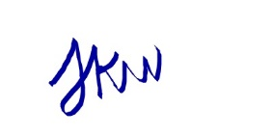  ______________________________  Signature
Date: 8-9- 2025 |  | Date: 9-9-2025

We must draw your attention to the following:
- You are required to replace items in angle brackets, e.g., ABC Cooking Pte Ltd for client.
- You must provide documents that are required to support:
- Operation of the system
- Maintenance of the system
- You are required to state the validity period of the link for source code.
- The system documentation must be in MS Word format.

